Farah Zahirotun Nisa

React B

Soal Prioritas 1

1. Buat Repository

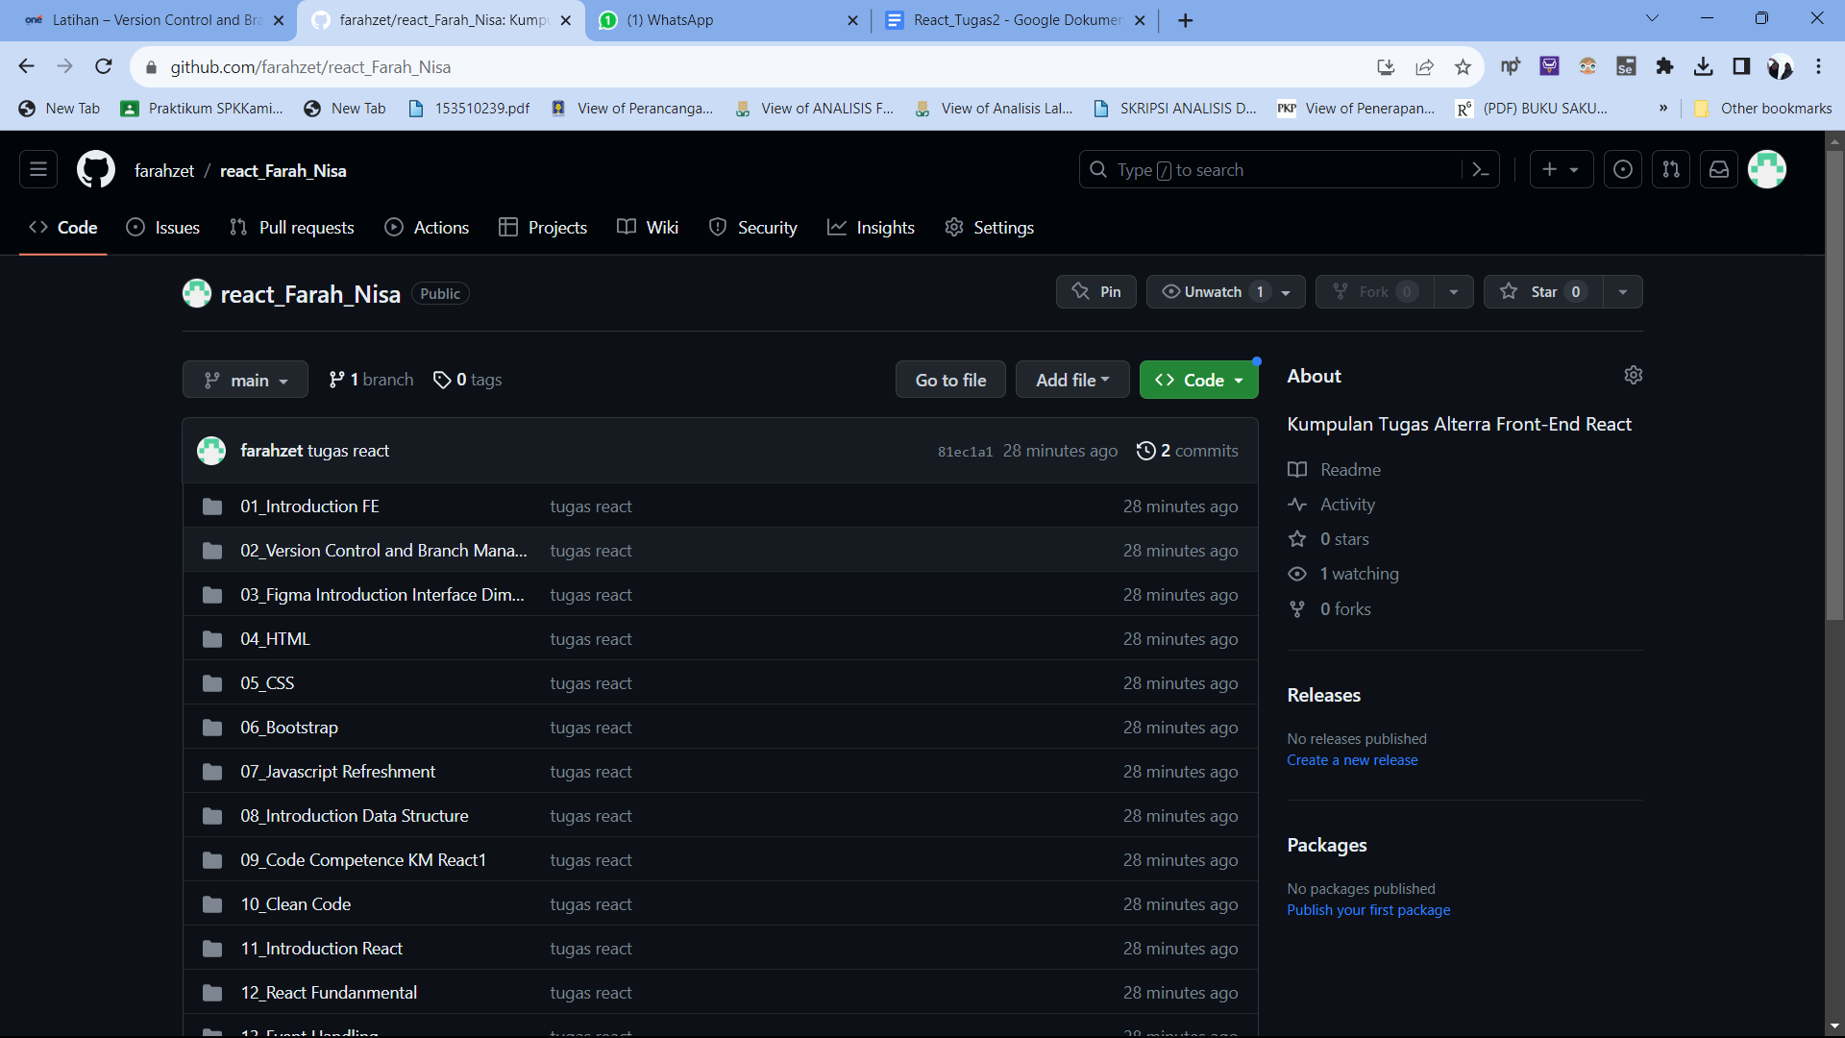

1. Buat Folder

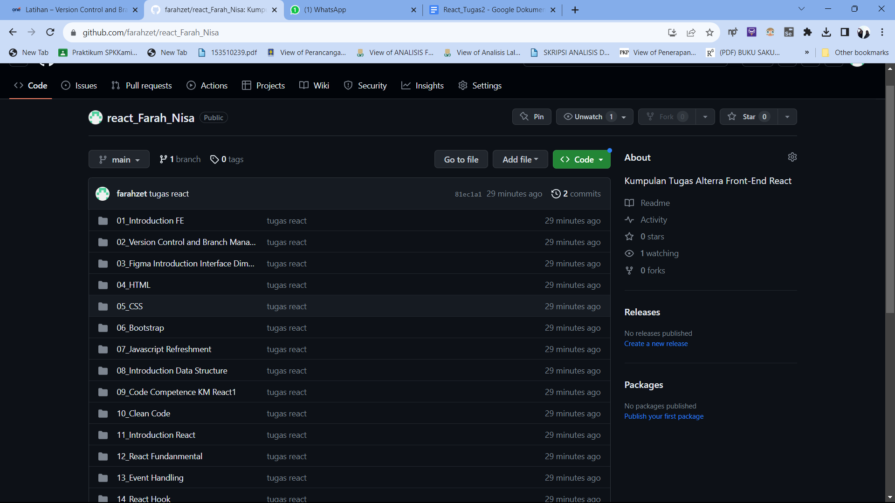

1. Buatlah Sub Folder

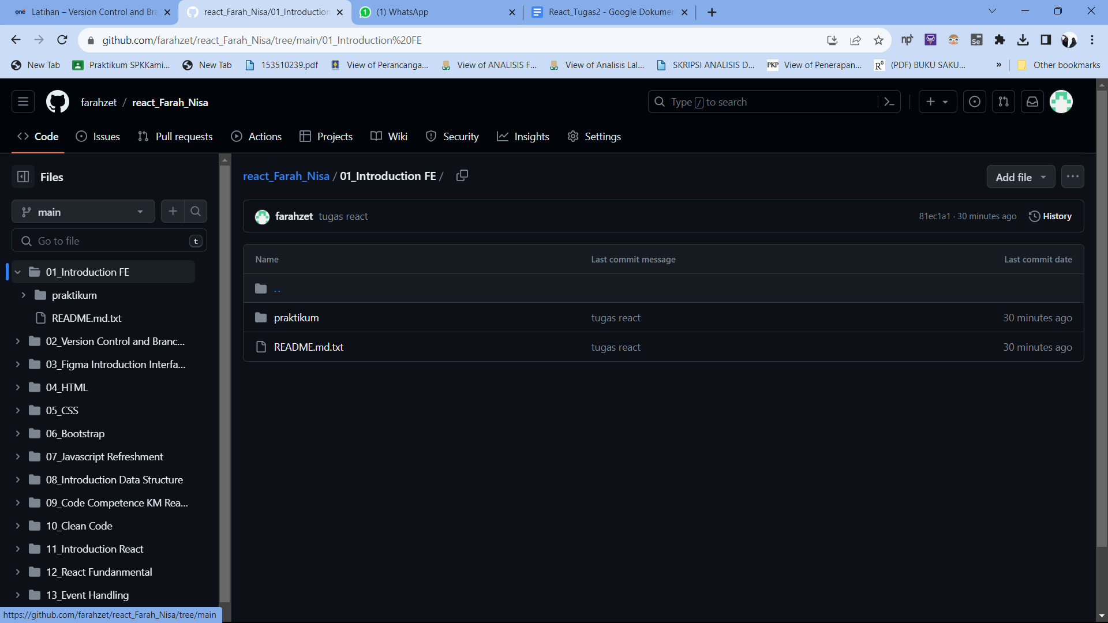

Soal Prioritas 2

1. Buat Branch

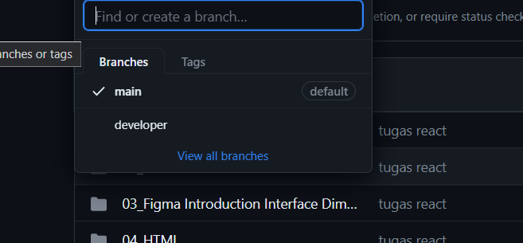

1. Pull Request

